AWS Project: Deploying a static website with AWS.

##AWS Services for the project

-VPC

-EC2

-Security group

-NAT gateway

-Classic Load Balancer

-Bastion Host instance

-Keypairs

### VPC Network Design:

-VPC IP Range:

4 subnets: 2 public subnets, 2 private subnets

2 zones: us-east-1a and us-east-1b

172.18.1.0/24 public-sub 1:us-east-1a

172.18.2.0/24 public-sub 2:us-east-1b

172.18.3.0/24 private-sub 1:us-east-1a

172.18.4.0/24 private-sub 2:us-east-1b

1 Internet gateway

1 NAT gateway

1 EIP

2 Route Tables: 1 Public subnet Route Table, 1 Private subnet Route Table

1 Bastion host in Pub subnet

## Deploying the website

-Let's login into our AWS account and for security reason, we can use an IAM user who have full administration privilege. If you don't have one and don't know how to create one, just follow this document: https://docs.aws.amazon.com/IAM/latest/UserGuide/id_users_create.html.

-Now, let get started with the project:

-Let's create the VPC first before other service. Navigate to the VPC console by searching VPC or using the service list option. I am going to create my VPC in the N.Virginia (us-east-1) region because I am closer to this region.

# Creating a VPC

-If you look at the VPC home page, we can see that I have 1 VPC, 6 subnets, 1 security group, etc. AWS always have default services in your account for security reasons because if we do not define a security option, then AWS would apply the default option for us.

# Creating a VPC with more than one subnets with my IP range: 172.18.0.0/16

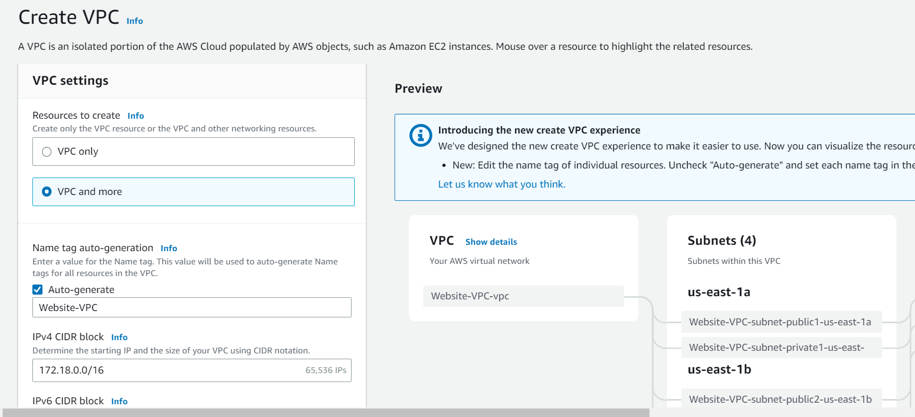

# Setting up my public and private subnets for my VPC

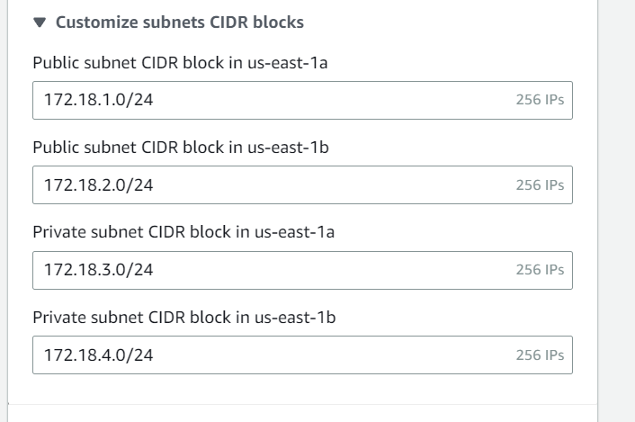

# Creating a NAT gateway in the public subnet and allocate an Elastic IP

# Launching a Centos7 instance for website

# Creating a bastion host instances in a public subnet

# Login into my bastion host instance from my computer

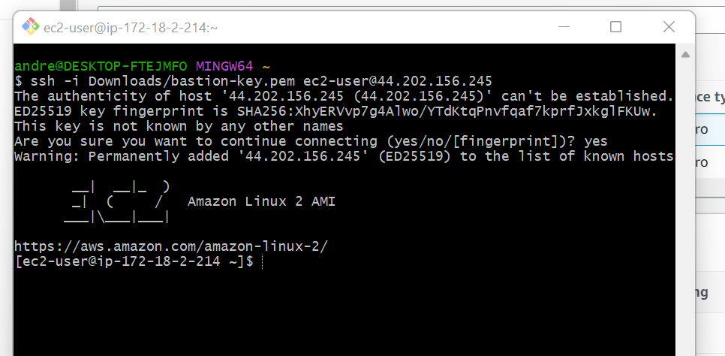

# Creating a load balancer

# The website is load balancer

# My two instances running

# Accessing my website using the load balancer DNS name

